CS 340 Grazioso Salvare Dashboard README

About the Project
This project is an interactive web dashboard for Grazioso Salvare, an innovative international rescue animal training company. The dashboard reads the Austin Animal Center (AAC) shelter outcomes data from a MongoDB database and helps Grazioso Salvare identify dogs that are potential candidates for three types of rescue categories: water, mountain or wilderness, and disaster or individual tracking.
The dashboard makes use of the AnimalShelter CRUD Python module. The dashboard does not talk to the database directly, instead it uses the Read operation of the module to interact with the database.

Files in this project
- ProjectTwoDashboard.ipynb – The dashboard application
- CRUD_Python_Module.py – the AnimalShelter class providing the CRUD operations: create(), read(), update(), and delete()
- Grazioso Salvare Logo.png – the client’s company logo that is displayed at the top of the dashboard.

Required Functionality
Grazioso Salvare requested a dashboard that allows the user to narrow the AAC shelter outcomes dataset down to dogs that match the requirements specific to the three rescue categories water, mountain and wilderness, and disaster or individual tracking using interactive filter options. The results of those filters will be displayed on a table, a chart, and a map. The dashboard provides the following:
- Branding and identification. The Grazioso Salvare logo is displayed at the top of the page and links to the SNHU website when clicked on. Below the logo features the developer’s name and date as a unique identifier.
- Interactive filtering. A set of radio buttons filters the data by rescue type: Water Rescue, Mountain or Wilderness Rescue, Disaster Rescue or Individual Tracking, and Reset (no filtering)
- Interactive data table. Results are shown in a paged table (10 records per page). A record can be chosen using the button in the left-most column and will be utilized in the geolocation map.
- Chart. A pie chart displays the breakdown of the preferred breeds based on the three rescue types. The chart updates automatically when the filter changes.
- Geolocation map. A Leaflet map displays a marker for the animal selected in the table. Hovering shows the breed and clicking shows the animal’s name.
- Graceful empty results. If a table filter returns no row, the dashboard will display a “No animals match the current filter” message. The chart and map will not display in this scenario.

Rescue-Type Filter Criteria
Each radio button contains a MongoDB query based on the criteria supplied by Grazioso Salvare. All three rescue types are limited to dogs, and age is compared using the age_upon_outcome_in_weeks field.
Rescue Type | Preferred Breeds | Preferred Sex | Training Age
Water | Labrador Retriever Mix, Chesapeake Bay Retriever, Newfoundland | Intact Female | 26 weeks to 156 weeks
Mountain or Wilderness | German Shepherd, Alaskan Malamute, Old English Sheepdog, Siberian Husky, Rottweiler | Intact Male | 26 weeks to 156 weeks
Disaster or Individual Tracking | Doberman Pinscher, German Shepherd, Golden Retriever, Bloodhound, Rottweiler | Intact Male | 20 weeks to 300 weeks
Reset | No filter | Any | Any

Proof of Functionality: Testing Screenshots
The screenshots below were taken while testing the dashboard.

Water Rescue Filter
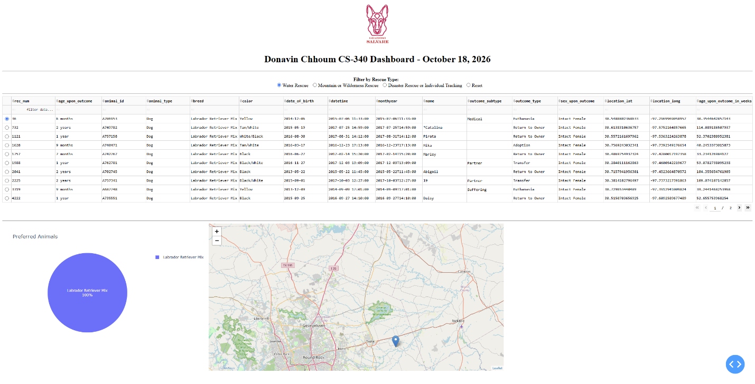

Mountain or Wilderness Rescue Filter
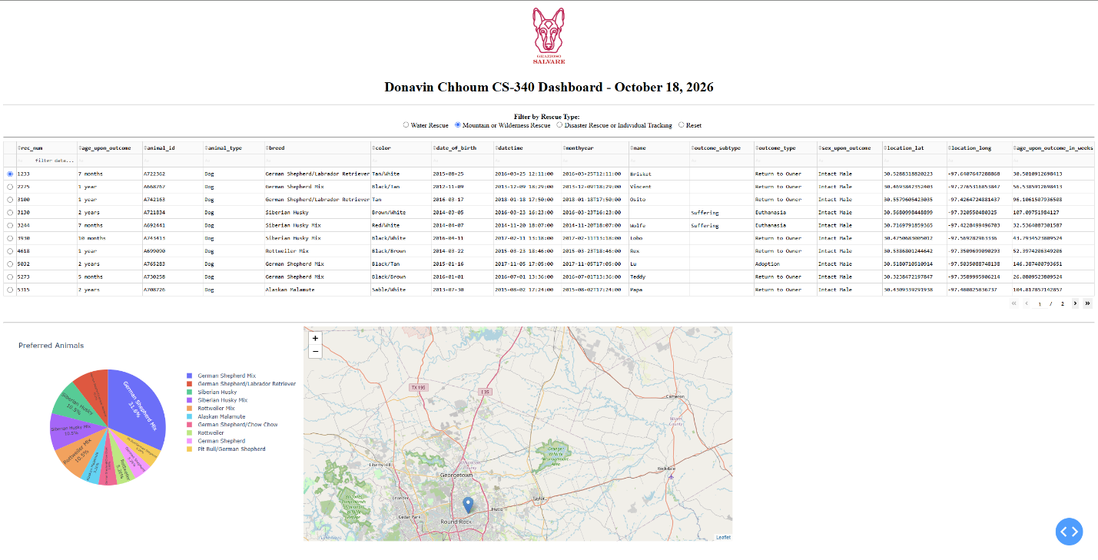

Disaster Rescue or Individual Tracking
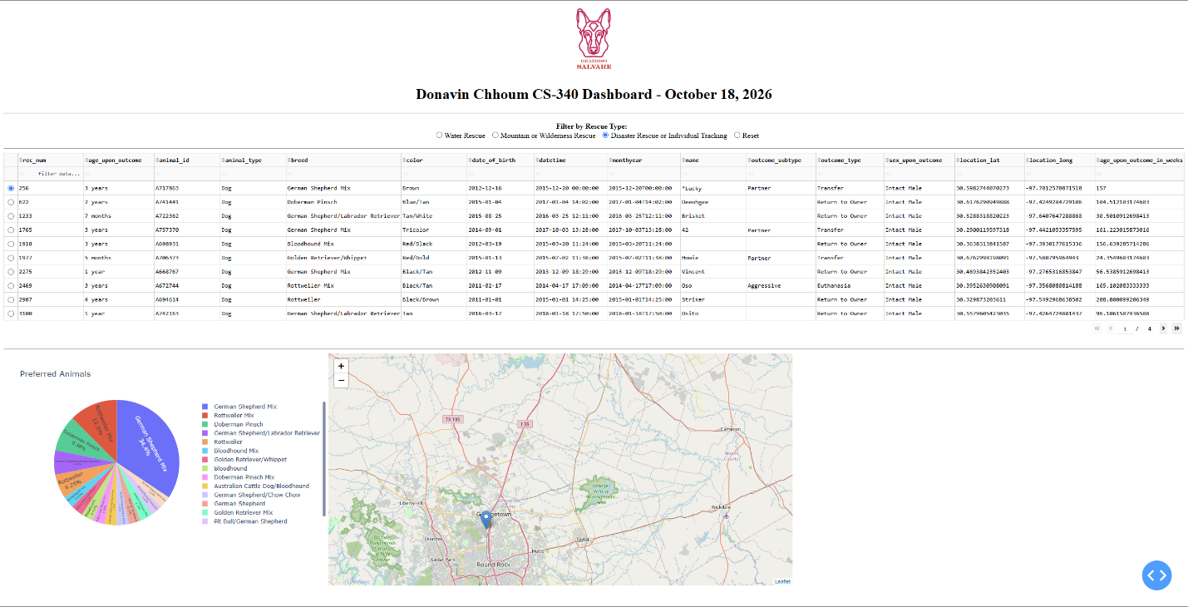

Reset/Starting Filter (No Filtering)
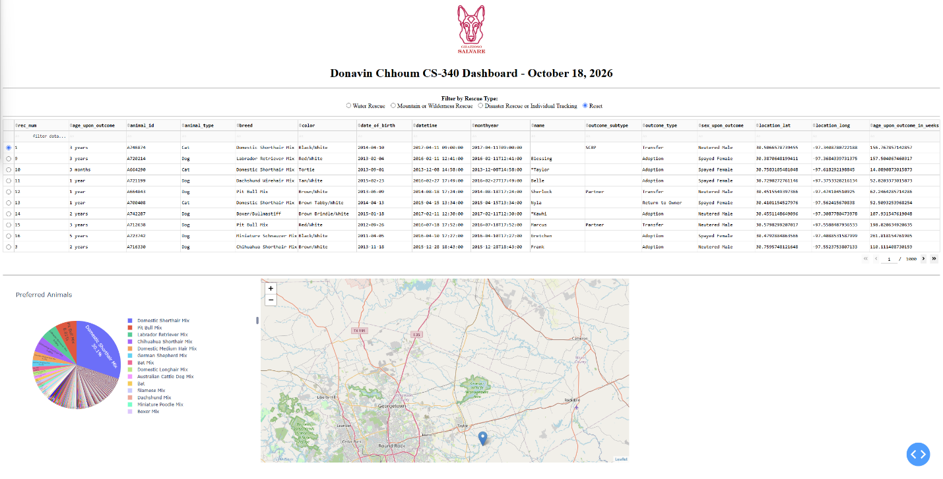
User-Input Filter (No Results)
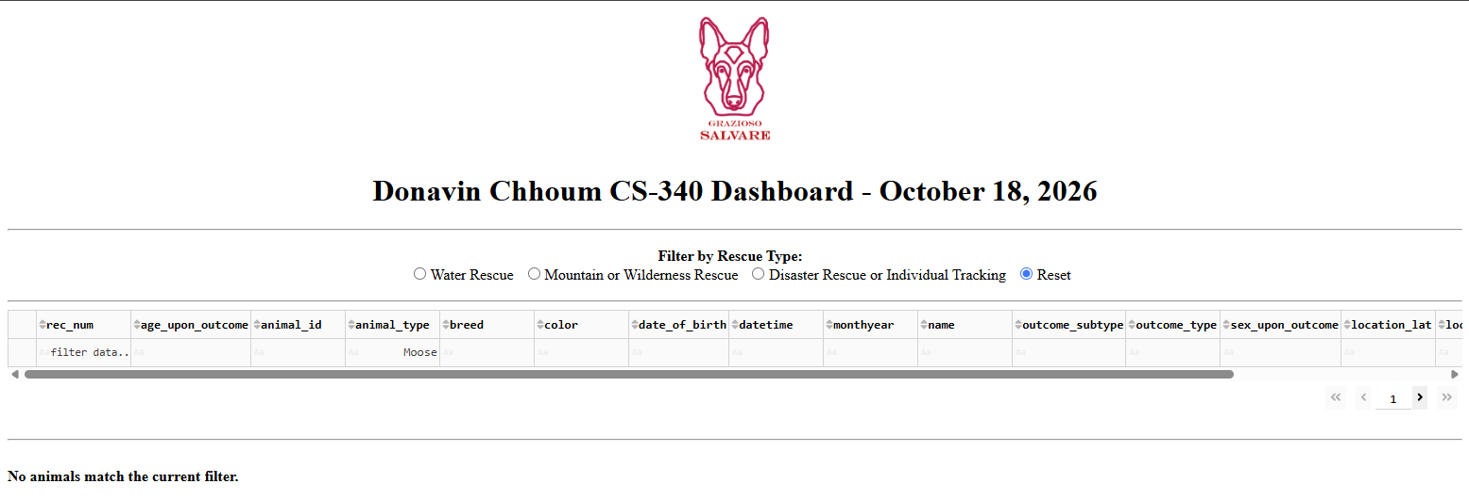
User-Input Filter (Results)
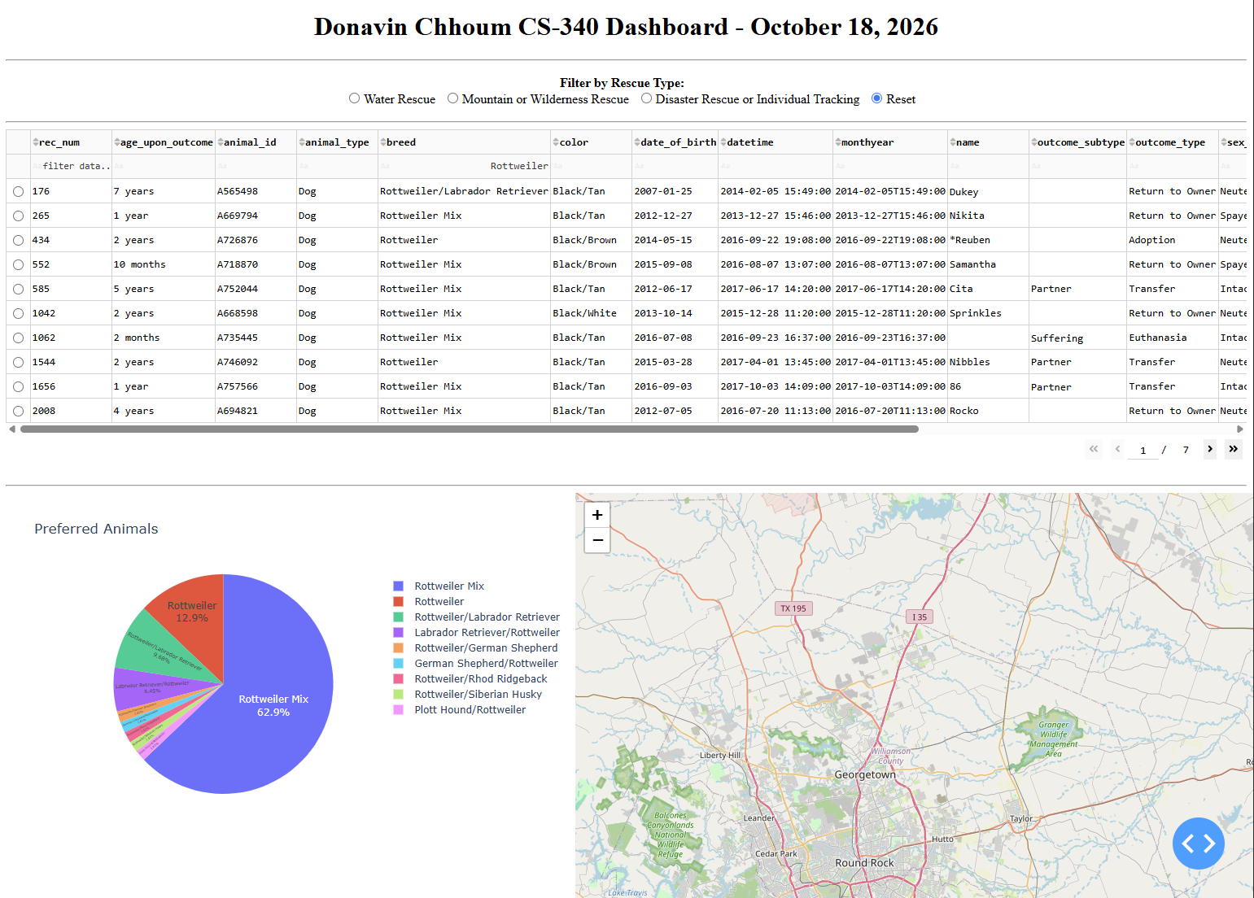

Geolocation Map Interactivity
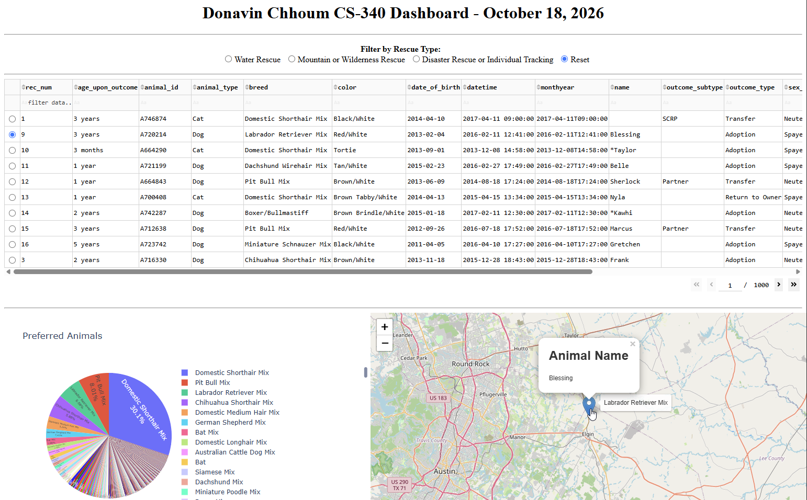

Logo Link to SNHU
Hovering over the Grazioso Salvare logo shows the link destination, https://www.snhu.edu, in the browser status bar at the bottom left. Clicking the logo opens the SNHU site in a new tab.
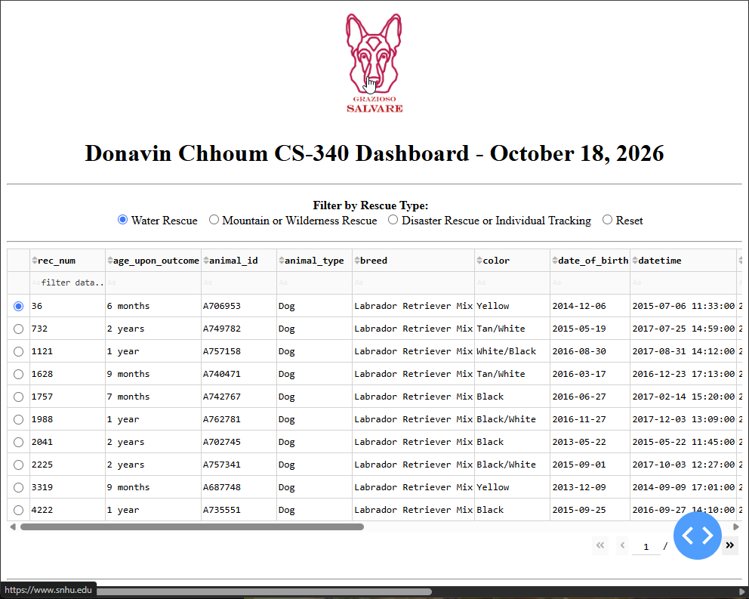

Tools Used and Rationale
- MongoDB was utilized to store the AAC shelter outcome records as flexible JSON-like documents that map directly into Python dictionaries.
- PyMongo is the official MongoDB driver for Python and is utilized inside the AnimalShelter CRUD module.
- Dash/JupyterDash was utilized to build the web interface and wires user input to updates, entirely in Python.
- Dash DataTable provides paging, native filtering and row selection.
- Plotly Express was utilized to create an interactive pie chart from a pandas DataFrame.
- Dash-leaflet renders the interactive Leaflet map for the geolocation display.
- Pandas converts the query results to a DataFrame, removes unsupported columns, and feeds the table and chart.
- Jupyter Notebook in Codio hosts the MongoDB instance, notebook and dashboard proxy in a singular workspace.

Why MongoDB was Used as the Model
MongoDB was utilized for several reasons:
- Document structure matches Python. MongoDB stores records as BSON documents made of key/value pairs, which PyMongo returns as ordinary Python dictionaries and lists.
- Flexible schema. Shelter records do not all have the same field. A document database handles missing and optional fields without requiring empty columns or a fixed table definition.
- Simple import and authentication. Mongoimport loads the CSV directly into a collection and role-based users allow a dedicated account with read/write access to only the aac database.
- Direct path to a DataFrame. The list of dictionaries returned by read() converts straight into a pandas DataFrame which is what the table, chart, and map utilize.

Dash Framework (View and Controller Structure)
In this project, Dash was utilized to provide the View and Controller Structure for the web application. This allows the whole front end to be written in Python.
- View – ‘app.layout’. The layout is a tree of components that contain the logo, title, radio item filters, the data table, and the two containers placed side by side for the pie chart and map.
- Controller – callbacks. Functions decorated with @app.callback declare which component properties are inputs and which are outputs. Dash runs the function whenever an input changes and sends the result to the output component. This is how a user action turns into a database query and a refreshed screen.

Resources and Software Used
- MongoDB - mongodb.com
- PyMongo - mongodb.com/docs/languages/python/pymongo-driver/current/
- Dash (Plotly) - dash.plotly.com
- Dash DataTable - dash.plotly.com/datatable
- Plotly Express - plotly.com/python/plotly-express
- Dash-leaflet - dash-leaflet.com
- JupyterDash - github.com/plotly/jupyter-dash
- Pandas - pandas.pydata.org
- Jupyter Notebook - jupyter.org
- Codio - codio.com
- Austin Animal Center open data - data.austintexas.gov/
- Southern New Hampshire University - snhu.edu

Steps Taken to Complete the Project
Below are the steps that can be followed to reproduce the project (note: sections of the code are provided by the institution, SNHU, and were not written by myself):
- Load the data. Move to the folder containing the aac_shelter_outcomes.csv file and import it into the aac database. This is done using mongoimport in the codio terminal.
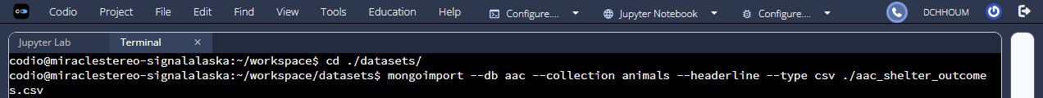
- Create the database user. Create the user aacuser in the admin database and give it the readWrite role for the aac database. This is done in the codio terminal.
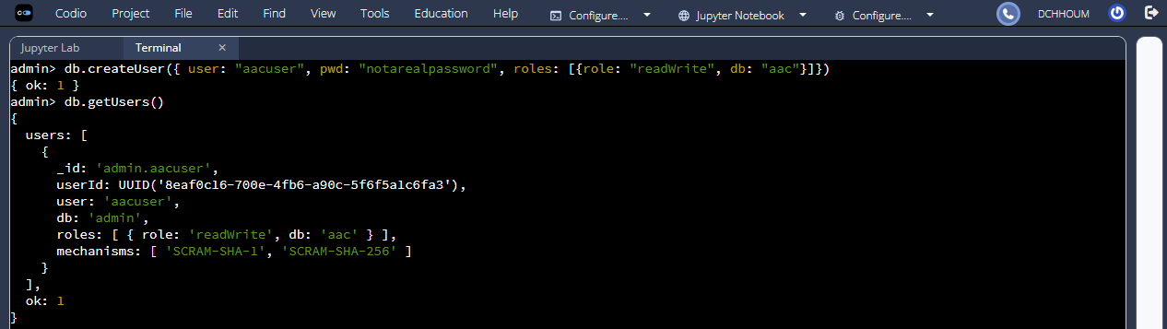
- Install the dashboard libraries. This is done in the codio terminal. Use the command:
pip install pymongo pandas numpy matplotlib plotly dash jupyter-dash dash-leaflet
Note: My codio environment had these libraries preinstalled. If your environment does not, then run the command above.
- Build the CRUD module. Write the CRUD_Python_Module.py with the AnimalShelter class and its create(), read(), update(), and delete() methods.
- Connect the notebook to the database. In ProjectTwoDashboard.ipynb, import AnimalShelter, create an instance with the aacuser credentials, and load all records with db.read({}) into a pandas DataFrame. Drop the _id column (not dropping _id will cause the data_table to crash).
- Design the layout. Add the logo, title with name and date, the radio button filters, the data table, and a flex row holding the chart and map containers.
- Configure the data table. Enable paging, native filtering, single-row selection with the first row preselected, and horizontal scrolling with ellipsis for long cell values.
- Write the filter callback. Translate each radio selection into a MongoDB query. Return the result to the table.
- Write the chart and map callbacks. Build the breed pie chart from derived_virtual_data and the map marker from the selected row, with an empty-result guard in both.
- Run and test. Launch the app with app.run_server(). Thoroughly test each feature of the application to ensure functionality.

Challenges I Faced
One challenge that I faced was that breed names in the data set are not exact matches for the breed filtering. For example, German Shepherd is a breed that exists in the data set, but German Shepherd Mix and German Shepherd/Labrador Retriever also exist in the data set. The requirements for the interactive filters include German Shepherd as a preferred breed so I decided that all dogs that list German Shepherd as a part of their breed should also be included. To achieve this, I created a helper method named breed_query() that builds an $or list of $regex matches so each preferred breed also catches its mixes and crosses.

Contact
Donavin Chhoum

